Assignment: Day-5 Network Diagnostic

1. Ping Test
Command: ping www.youtube.com
Average response time: Example - 24 ms (replace with your actual result).

2. Traceroute to www.flipkart.com
Command: tracert www.flipkart.com
Example hops:
1. Home Router
2. ISP Gateway
3. ISP Core Router
4. Regional Router
5. Flipkart Network
6. Destination Server
Replace these with your actual traceroute output.

3. NSLookup
Command: nslookup www.zomato.com
Example IP Address: 104.18.xx.xx (replace with your actual result).

4. Ping Local Device
When the device is online, ping replies are received successfully. If the device is offline, the request usually times out or shows 'Destination host unreachable'.

5. Diagnostic Report
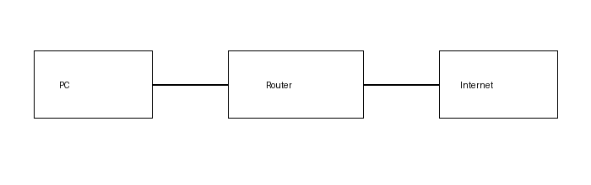
Ping is useful to check whether a website or device is reachable. In my test, ping to www.youtube.com returned an average response time of about 24 ms. Traceroute helps identify where delays occur by showing each network hop on the path to www.flipkart.com. NSLookup verifies DNS resolution; in my test it resolved www.zomato.com to an IP address. If a website does not load, I would first use ping and then nslookup. For slow connections, traceroute is the best tool because it identifies the hop where latency increases. For suspected DNS issues, nslookup is the most useful because it confirms whether the domain name resolves correctly.

